Application: Data Encryption and Security Algorithm
Aim:
To design and analyze a secure data encryption algorithm that divides data recursively and applies encryption operations at each level. The recurrence relation is:
$$T\left(n\right)=2T\left(n/2\right)+n$$
We aim to determine the time complexity using the Master Theorem and evaluate its performance for large datasets.
Problem Statement
A data encryption system encrypts a dataset of size $n$by splitting it into two halves recursively. Each half is encrypted separately, and linear work $n$is done for combining and key generation. We must:
- Apply the Master Theorem to find time complexity.
- Analyze scalability and efficiency for large data.
- Interpret results using asymptotic notation.
Algorithm
- Define recurrence: $T\left(n\right)=2T\left(n/2\right)+n$
- Compare with Master Theorem form: $T\left(n\right)=aT\left(n/b\right)+f\left(n\right)$
  - $a=2,b=2,f\left(n\right)=n$
- Compute $\log_{b}a=\log_{2}2=1$
- Since $f\left(n\right)=n=n^{\log_{b}a}$, → Case 2 of Master Theorem applies.
- Therefore,
$$T\left(n\right)=O\left(n\log{n}\right)$$

Source Code
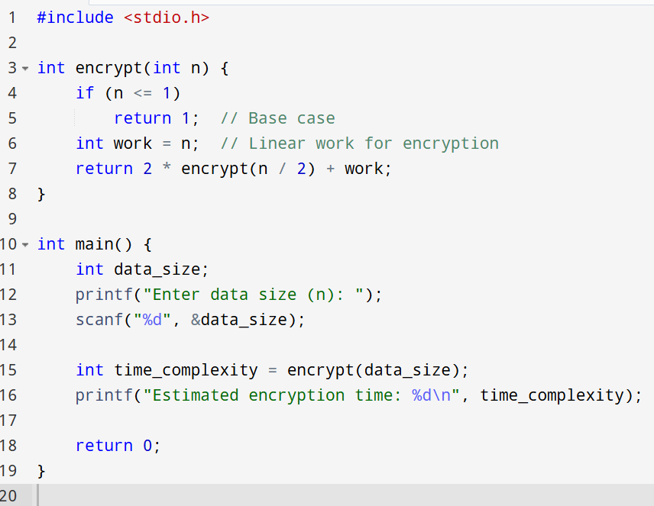
Input And Output
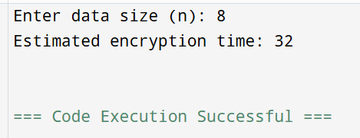

Performance Analysis:
Parameter | Description | Result
Recurrence | $$T\left(n\right)=2T\left(n/2\right)+n$$ | Divide and combine
Method Used | Master Theorem | Case 2
Time Complexity | $$O\left(n\log{n}\right)$$ | Log-linear growth
Space Complexity | $$O\left(\log{n}\right)$$ | Recursive depth
Scalability | Good | Handles large data efficiently
Efficiency | Moderate | Slight overhead due to recursion
Growth Rate | Log-linear | Faster than quadratic algorithms
Application
Used in data encryption, secure file transfer, and cryptographic key generation systems where recursive division improves parallelism and security layering.
Advantages
- Efficient Encryption: Log-linear time ensures fast encryption for large files.
- Parallelizable: Each half can be encrypted independently.
- Scalable: Works well for distributed or cloud-based encryption.
- Predictable Performance: Time grows moderately with data size.
Limitations
- Recursive Overhead: Function calls increase memory usage.
- Limited for Small Data: Overhead may outweigh benefits for small datasets.
- No Adaptive Optimization: Uniform division may not suit all encryption patterns.
Result
After applying the Master Theorem,
$$T\left(n\right)=O\left(n\log{n}\right)$$
The encryption algorithm achieves log-linear time complexity, balancing speed and scalability. It is ideal for secure, large-scale data encryption with predictable performance.

